Steps of Submitting the Information about Opening Report on GMS System
the procedure is as follows:
1. click Xw
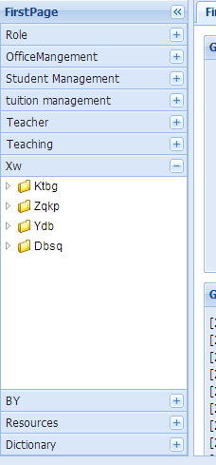
- click Ktbg
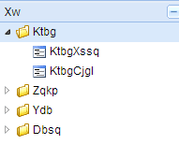
- click KtbgXssq
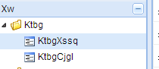
- click add and then write information about your own opening report
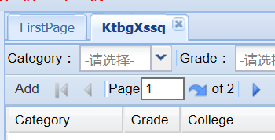
- Please ask your own supervisor to audit your opening report application on GMS system, finished!

